**Step 1: Install Playwright**

[**https://angular.dev/tutorials/learn-angular**](https://angular.dev/tutorials/learn-angular)

[**https://playwright.dev/docs/intro**](https://playwright.dev/docs/intro)

npm i -D @playwright/test

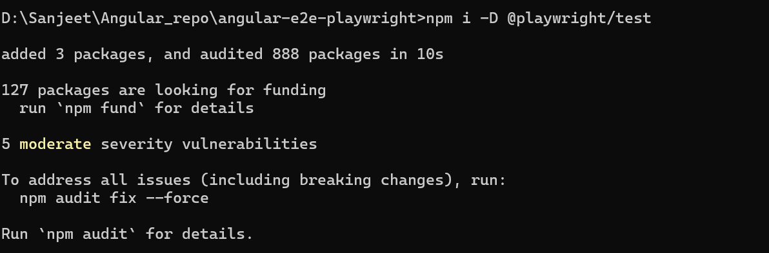

**Step 2: Initialize Playwright**

npm init playwright

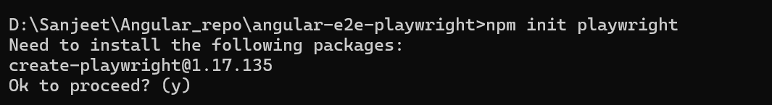

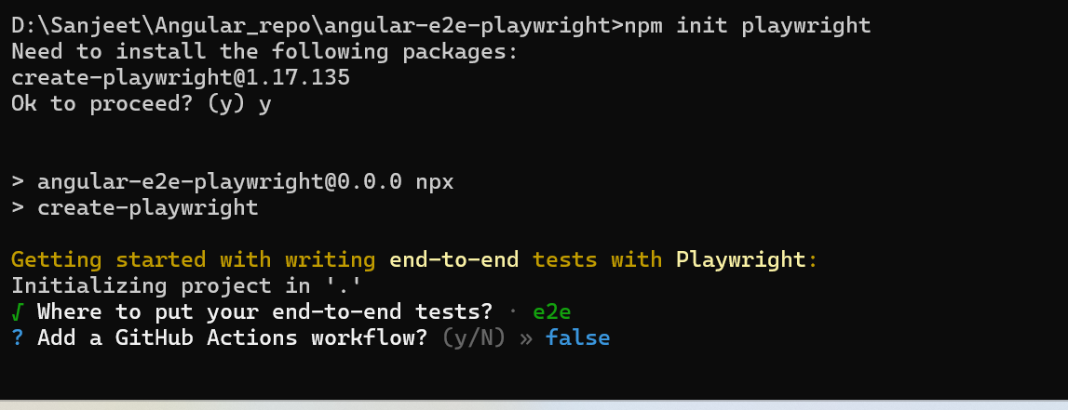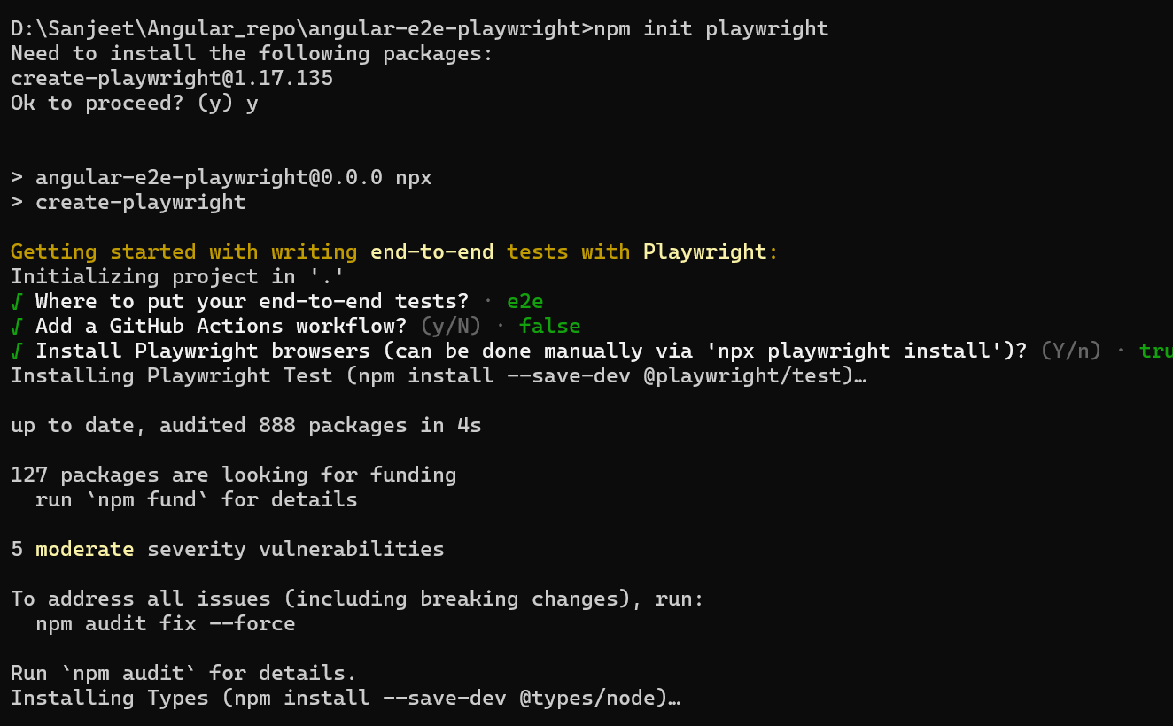

**Step 3: Add Playwright Config for Angular**

Open playwright.config.ts and update this:

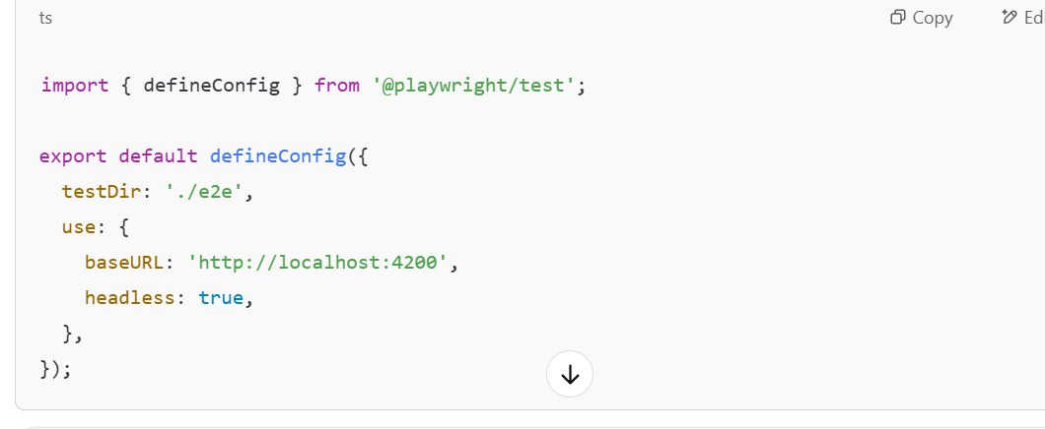

**Step 4: Create First Test**

In e2e/example.spec.ts, replace the code with:

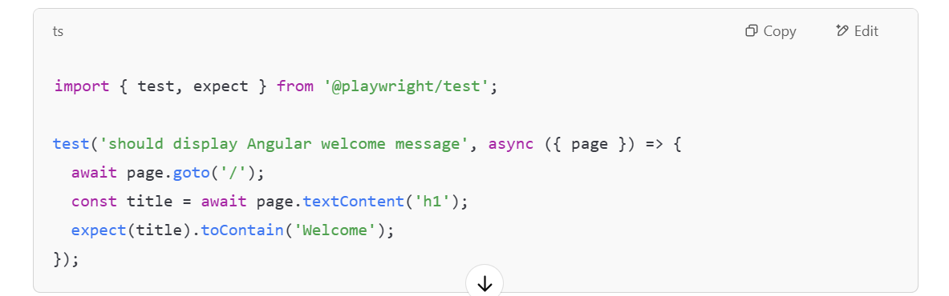**Step 5: Run Angular and Playwright**

Open two terminals:

1️⃣ **Run Angular app**

ng serve

2️⃣ **Run Playwright tests**

npx playwright test

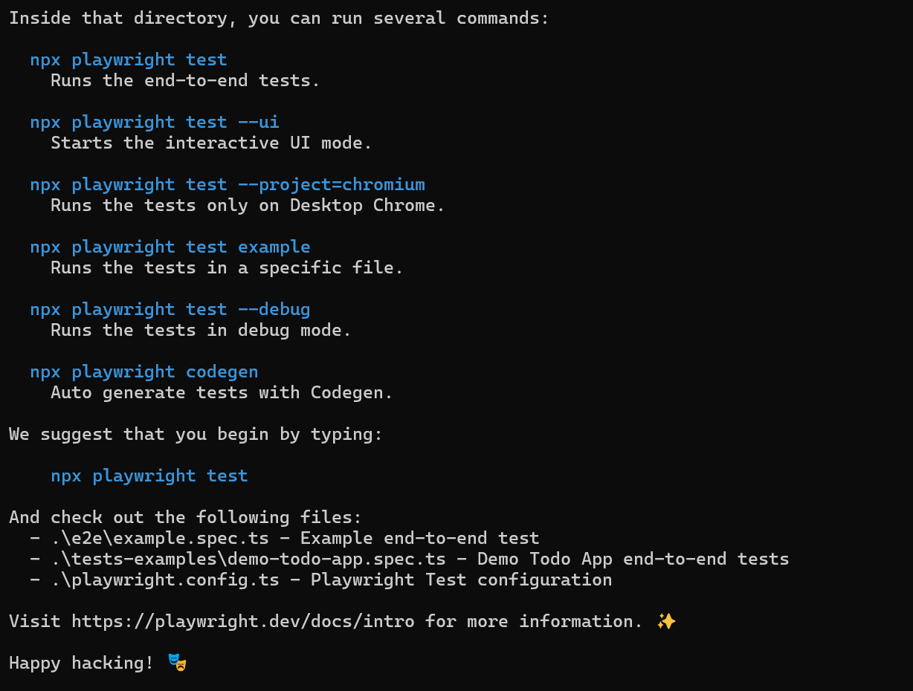

This file automatically created:

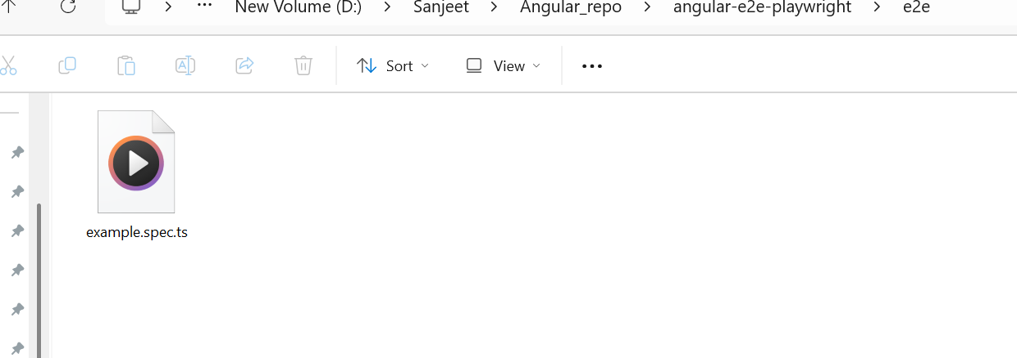

This folder also created



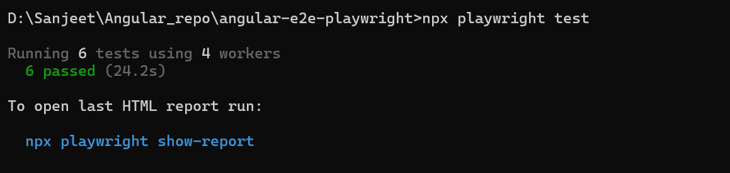

npx playwright show-report

<http://localhost:9323/>

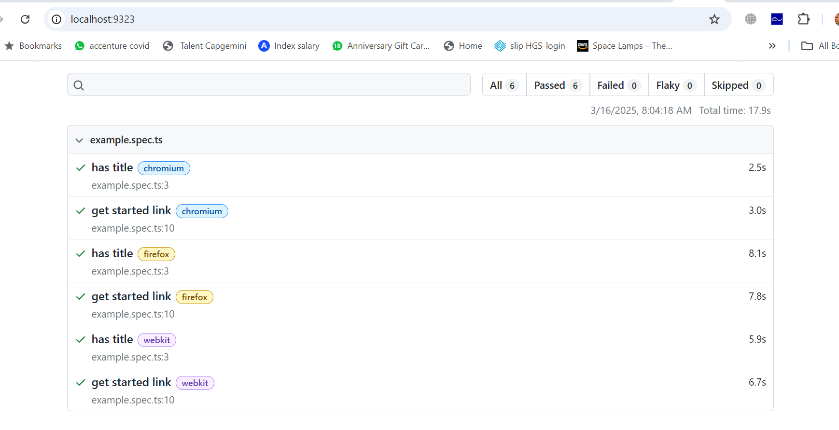

Added one more e2e test

